BREAKFAST CHATTER
Weekly Bulletin of Rotary Club of Kathmandu Mid-Town
District 3290 Volume No. 15/35 for #777 March 25, 2005
www.rotarymidtown.org.np
MARCH IS POLIO PLUS & ROTARACT (WEEK) MONTH
FINALLY AGAIN THERE IS SUNSHINE! (ALTHO NOT FOR THE PICNIC)
In the week of 18 March, 2005 we greet Mani on the 28th and Robin (in absentia, but—remember he’s coming soon!) Low carb cake anyone?
****************
MEETINGS & ACTIVITIES:
DATE | ACTIVITY | SUBJECT
25 MAR | MUNI SAKYA | DEVELOPING HIGH TECH ACTIVITIES IN NEPAL
1 APR | PEMA KHANDO | FASHION DEVELOPMENT IN NEPAL
9 APR | POWER BREAKFAST | KIRTIPUR SCHOOL SATURDAY MORNING
13 APR | DINNER MEETING ROBIN BRADSHAW | LONDON TO CAPETOWN AND BACK BY SCOOTER  (IN HIS YOUTH)
22 APR | CLUB ASSEMBLY | PROGRESS REPORTS
29 APR | SOM PANERU | OVERCOMING KAMLARIA
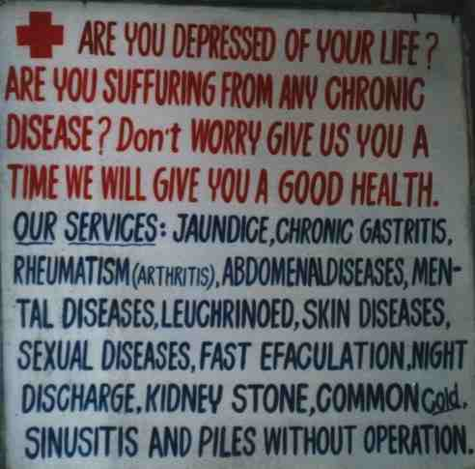
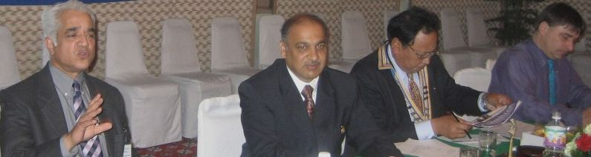
****** Many health care professionals have spoken to MidTown, and as Ashok Banskota noted last Friday, many of us have been their patients. But perhaps we have not tapped as speakers the full range of talent (medical and media) available in the valley. The photo to the left indicates some extraordinary services available if you only take time to look around. Just “give us you a time we will give you a good health”. Good health to all! ****** My apologies to all who were prepared, packed and ready to picnic last Saturday. The condition Friday night was very wet, the forecast not any better. As it turned out we might have managed, but with wet ground and grass. A new date will be set – hopefully with brighter skies.
^^^ Dr. Ashok Banskota describing the work and successes of HRDC ^^^^
This Friday Muni Sakya will share his experience as an entrepreneur in bringing high tech to Nepal.

Hope to see you on Friday morning. YIR…David

